Exercises- Predicate Logic
Exercise 1
Transform the following sentences from natural language into predicate formulas. Explain the syntactic elements used in the predicate formulas: variables, constants, functions symbols, predicate symbols.
- In a plane if a line is perpendicular to a constant line then all the lines parallel to are perpendicular to .
- In a plane there are lines parallel to a constant line and there are lines perpendicular to .
- If is a nonzero integer divisible by 10, it can be decomposed in two factors such that one is divisible by 2 and the other one is divisible by 5, and can be written as a sum of 2 even numbers.
- Every positive number can be written as a product of two positive numbers and as a product of two negative numbers.
- If and are positive prime numbers, 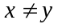, 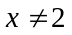 and 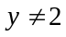, their sum and difference are even numbers and their product is an odd number.
- For every positive integer , if is a square of an integer, then there exists an integer y such that 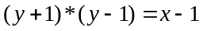.
- For every positive integer , if is not a prime, then there exists a prime such that divides and is smaller than .
- The sum of two even numbers is an even number and their product is divisible by 4.

Exercise 2
Transform the following statements from natural language into predicate formulas choosing the appropriate constants, function symbols and predicate symbols:
- Every student who makes good grades is brilliant or studies.
- Some of John’s colleagues like to draw and some like to dance.
- CS students like either algebra or logic, all of them like Java but only Bill likes history.
- All Mary’s relatives live in Cluj-Napoca, only her cousin John lives in Bucharest.
- Anyone who owns a rabbit hates anything that chases any rabbit.
- All birds have wings but only penguins do not fly.
- If Santa has some reindeer with a red nose, then every child loves Santa.
- Every investor who bought something that falls is not happy.
- Anyone who has any cats will not have any mice.
- Caterpillars and snails are much smaller than birds, which are much smaller than foxes, which in turn are much smaller than wolves.
- Caterpillars and snails like to eat some plants.
- Every animal either likes to eat all plants or all animals much smaller than itself that like to eat some plants.

Exercise 3
Using the definition of deduction in predicate logic prove:
- ;
- ;
- ;
- ;
- 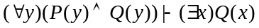;
- 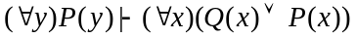;
- ;
- .

Exercise 4
Using the given interpretations evaluate the following formulas:
Interpretation 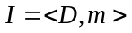, where:
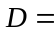 the set of all straight lines of a plane
Let 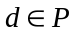, a constant straight line belonging to the interpretation domain
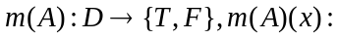”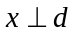”; 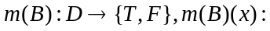”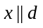”;
Interpretation where N (the set of natural numbers)
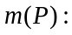N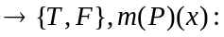”x5”;
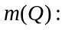N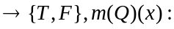”x7”;

- 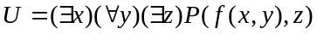
Interpretation , where Z (the set of integer numbers),
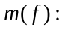Z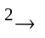Z, 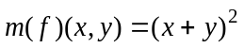 and
Z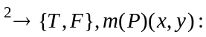”x > y”;

Interpretation , where the set of all triangles,
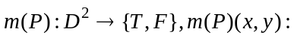”Area(x) Area(y)”;

Interpretation , where N (the set of natural numbers)
NN, 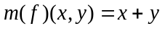 and 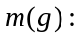NN, 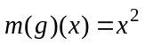
N”x = y”;

Interpretation , where:
the set of all persons from Cluj county
”the person has a driver license”;
”the person owns a car”.

- 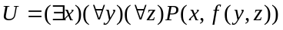
Interpretation , where Z (the set of integer numbers),
ZZ, and
Z”x < y”;

Interpretation , where:
the set of all persons from Romania
”the person lives in a city”;
”the person has a job”.

Exercise 5
Prove that the following formulas are not valid by finding anti-models for them.
- ;
- ;
- ;
- ;
- ;
- ;
- .

Exercise 6
Choose an arbitrary interpretation for the formula 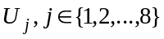 and prove that it is a model of .
- ;
- ;
- ;
- ;
- ;
- ;
- ;
- .

Note: All the formulas from are tautologies.

Exercise 7
Transform the following formulas into prenex, Skolem and clausal normal forms.

- ;
- ;
- ;
- ;
- ;
- ;
- ;
- .

Exercise 8
Transform the following formulas into prenex, Skolem and clausal normal forms.
- ;
- ;
- ;
- ;
- ;
- ;
- ;
- .

Exercise 9
Are the literals from the following pairs unifiable? If yes, find their most general unifier.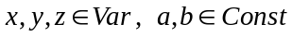, 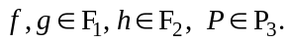

- 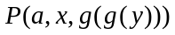 and 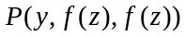;
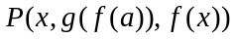 and 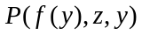;
and 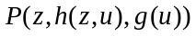;

- 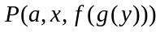 and ;
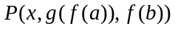 and 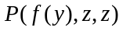;
and 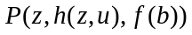;

- 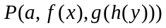 and 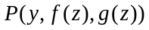;
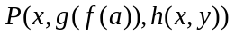 and 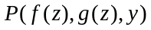;
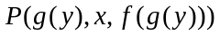 and 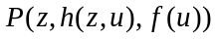;

- 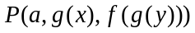 and 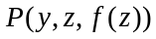;
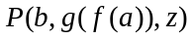 and 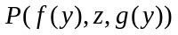;
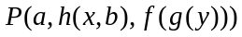 and ;

- 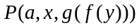 and 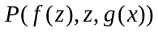;
and 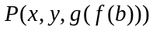;
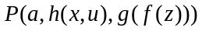 and 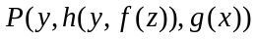;

- 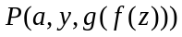 and 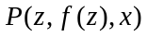;
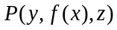 and 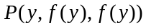;
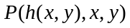 and 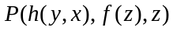;
- and 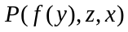;
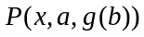 and 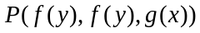;
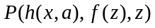 and 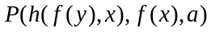;

- and 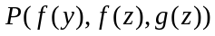;
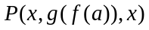 and 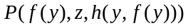;
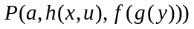 and 

